|  |
| --- |
| **Unlocking The HR Schema** |

* **Script for Unlocking The HR Schema**

|  |
| --- |
| sqlplus / as sysdba;  alter session set container=orclpdb;  alter pluggable database open;  alter pluggable database orclpdb save state;  alter user hr identified by hr account unlock;  / |

* **Steps For Unlocking The HR Schema**
* First we need to open the command prompt and paste the code given above
* We might face a problem while unlocking the HR user as shown below

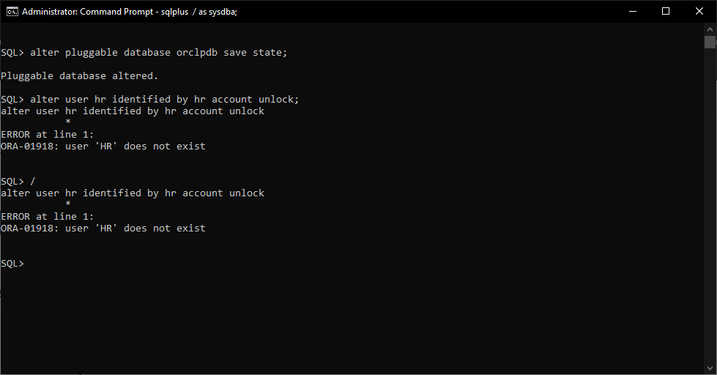

* This error occurs because the sample schemas donot come with the installed Oracle DB version. So we must manually install them
* However, we need to test if they really donot exist on our system

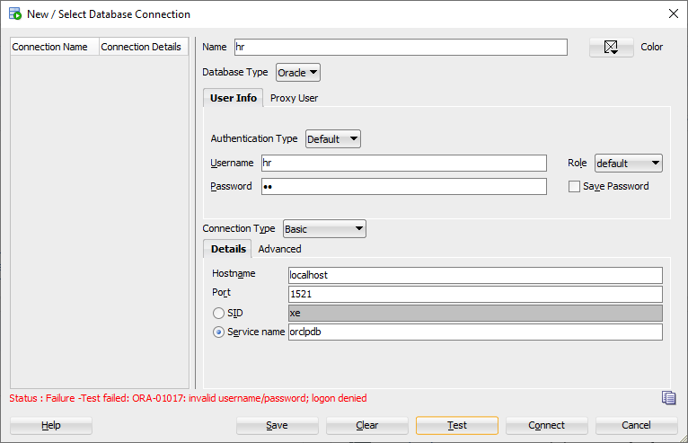

* We need to write the following script to solve the issue

|  |
| --- |
| sqlplus sys/123@localhost:1521/orclpdb as sysdba;  alter pluggable database open;  alter pluggable database orclpdb save state;  create or replace directory import_dir as 'C:\SAMPLE_SCHEMAS';  exit  impdp system/123@localhost:1521/orclpdb schemas=hr directory=import_dir dumpfile=EXPORTED_SAMPLE_SCHEMAS.dmp logfile=import.log remap_tablespace=EXAMPLE:USERS  impdp system/123@localhost:1521/orclpdb schemas=sh directory=import_dir dumpfile=EXPORTED_SAMPLE_SCHEMAS.dmp logfile=import.log remap_tablespace=EXAMPLE:USERS  impdp system/123@localhost:1521/orclpdb schemas=oe directory=import_dir dumpfile=EXPORTED_SAMPLE_SCHEMAS.dmp logfile=import.log remap_tablespace=EXAMPLE:USERS  impdp system/123@localhost:1521/orclpdb schemas=pm directory=import_dir dumpfile=EXPORTED_SAMPLE_SCHEMAS.dmp logfile=import.log remap_tablespace=EXAMPLE:USERS  impdp system/123@localhost:1521/orclpdb schemas=ix directory=import_dir dumpfile=EXPORTED_SAMPLE_SCHEMAS.dmp logfile=import.log remap_tablespace=EXAMPLE:USERS  sqlplus sys/123@localhost:1521/orclpdb as sysdba;  alter user hr identified by hr account unlock;  alter user sh identified by 123 account unlock;  alter user oe identified by 123 account unlock;  alter user pm identified by 123 account unlock;  alter user ix identified by 123 account unlock;  / |

* After the script is executed successfully, we will see that all the schemas will be available for connection
* We can see that the test status is success, which means all the schemas have been imported successfully

